**DIGITAL WORKER ASSISTANT**

A

Project Report

Submitted in partial fulfillment of the requirement for the award of degree of

#### Bachelor of Technology

In

#### Information Technology

Submitted to

#### RAJIV GANDHI PROUDYOGIKI VISHWAVIDYALAYA, BHOPAL (M.P.)



**Guided by Submitted By**

Prof. Deepesh Shrivas Ayush Gour (0832IT201012)

#### DEPARTMENT OF INFORMATION TECHNOLOGY CHAMELI DEVI GROUP OF INSTITUTIONS INDORE (M.P.) 452020

**2022-23**

**DIGITAL WORKER ASSISTANT**

#### *A Minor Project*

***Software Requirement Specification Report submitted to***

***Rajiv Gandhi Proudyogiki Vishwavidyalaya, Bhopal***

## Bachelor of Technology

in Information Technology

***by***

**Ayush Gour (0832IT201012)**

***Under the guidance of***

### Prof. Deepesh Shrivas

**(Assistant Professor)**



**Session: 2022-23 Department of Information Technology Chameli Devi Group of Institutions, Indore**

**452 020 (Madhya Pradesh)**

### DECLARATION

We certify that the work contained in this report is original and has been done by us under the guidance of my supervisor(s).

1. The work has not been submitted to any other Institute for any degree or diploma.
2. We have followed the guidelines provided by the Institute in preparing the report.
3. We have conformed to the norms and guidelines given in the Ethical Code of Conduct of the Institute.
4. Whenever we have used materials (data, theoretical analysis, figures, and text) from other sources, we have given due credit to them by citing them in the text of the report and giving their details in the references.

**Name and Signature :**

|  |  |  |  |
| --- | --- | --- | --- |
| **Sr.**  **No.** | **Enrollment No.** | **Name of students** | **Signature of students** |
| 1. | 0832IT201012 | Ayush Gour |  |

**CHAMELI DEVI GROUP OF INSTITUTIONS, INDORE**



## CERTIFICATE

Certified that the minor project report entitled, “**Digital Worker Assistant** ” is a bonafide work done under my guidance by Ayush Gour ,partial fulfillment of the requirements for the award of degree of Bachelor of Technology in Information Technology Engineering.

Date:

(Prof. Deepesh Shrivas )

Guide

__________________________ _________________________

(Prof. Radheshyam Acholiya) (Prof. Deepesh Shrivas)

Head of the Department

**CHAMELI DEVI GROUP OF INSTITUTIONS, INDORE**

**ACKNOWLEDGEMENT**

We have immense pleasure in expressing our sincerest and deepest sense of gratitude towards our guide Prof. Deepesh Shrivas for the assistance, valuable guidance and co- operation in carrying out this Project work. We are developing this project with the help of Faculty members of our Institute and we are extremely grateful to all of them. We also take this opportunity to thank Head of the Department Prof. Radheshyam Acholiya, and Principal Dr. Manish Shrivastava, for providing the required facilities for the project work. We are greatly thankful to our parents, friends and faculty members for their motivation, guidance and help whenever needed.

#### Name and Signature of Team Members:

1. Ayush Gour ………………..

**TABLE OF CONTENTS**

|  |  |
| --- | --- |
| CONTENTS | Page No. |
| Title Page | I - II |
| Declaration | III |
| Certificate by the Supervisor | IV |
| Acknowledgement | V |
| Table of Contents | VI - VII |
| List of Figures | VIII |
| Abstract | IX |
| Chapter 1: Introduction | 1 |
| 1.1 Rationale | 1 |
| 1.2 Goal | 1 |
| 1.3 Objective | 2 |
| 1.4 Methodology | 2-4 |
| 1.5 Role | 5 |
| 1.6 Contribution of Project | 6 |
| 1.6.1 Market Potential | 6 |
| 1.6.2 Innovativeness | 6 |
| 1.6.3 Usefulness | 6 |
| Chapter 2: System Features | 7 |
| 2.1 Functional Requirement Collection | 7 |
| 2.2 Non-Functional Requirement | 7 |
| 2.2.1 Performance Requirement | 7 |
| 2.2.2 Safety Requirement | 8 |
| 2.2.3 Software Quality Attributes | 8 |
| 2.3 External Interface Requirement | 8 |
| 2.3.1 Hardware Interface | 8 |
| 2.3.2 Software Interface | 8 |
| Chapter 3: Analysis & Design | 8 |
| 3.1 Use-case Diagram | 9 |
| 3.2 Activity Diagram | 10 |
| 3.3 E-R Diagram | 11 |

|  |  |
| --- | --- |
| 3.4 Class Diagram | 12 |
| 3.5 Data Flow Diagram | 13 |
| 3.6 Sequence Diagram | 14 |
| Chapter 4: Construction | 15 |
| 4.1 Implementation | 15 |
| 4.1.1 Implementation Details | 15 |
| 4.1.2 Database Tables | 15 |
| 4.2 Testing | 15 |
| 4.2.1 White Box Testing | 15 |
| 4.2.2 Black Box Testing | 15 |
| 4.2.3 Test Cases | 16 |
| References | 17 |
| Conclusion | 18 |

**LIST OF FIGURES**

|  |  |  |
| --- | --- | --- |
| **S.NO.** | **FIGURE NAME** | **PAGE NO.** |
| 1) | USE CASE DIAGRAM | 09 |
| 2) | ACTIVITY DIAGRAM | 10 |
| 3) | E-R DIAGRAM | 11 |
| 4) | CLASS DIAGRAM | 12 |
| 5) | DATA FLOW DIAGRAM | 13 |
| 6) | SEQUENCE DIAGRAM | 14 |

**ABSTRACT**

Now a day, people are finding difficulties in finding the right workers to do their work .Daily wages worker may not be available when they are required or may not be efficient in their work. Also, many workers will not get work daily and they may feel difficulty to satisfy their daily needs. This cause a serious problem to the person whose work is to be done. The main part of this project is to develop an automated system which build a communication path and strengthen the customer-worker relationship. This system also helps to reduce the time and effort in searching workers efficiently. Also, this system makes a worker to obtain suitable work of his/her category throughout the year and enhance his/her financial status.

# Chapter 1: Introduction

### Rationale

In today’s scenario, one is dependent on the internet. In this project, the worker’s empowerment is an important motive. Many time’s we hear in newspapers, news media, and various other media that workers are not getting their committed daily wages from their contractors or owners. Now a day, peoples are finding it difficulties in finding the right workers to do their work done. . Also, many workers will not get works daily and they may feel difficulty to satisfy their daily needs. The main reason for creating this application is to avoid these problems we have proposed a application where anybody can book any workers based on their location or area. System will allow workers to register themselves with the application at any time. Registered worker information is processed and presented to customer. Customer can select any labors (worker) for which an intimation E-mail will be sent to the admin of the system with required information. Admin, in turn communicate with the concerned worker and worker may be appointed to work at customer’s place. Once the work is completed, the worker approaches the admin of the system and provides work information. Based on this, Admin will send the bill information to the concerned customer to pay. This system will allow the admin to generate various reports to keep track of both customer and worker information. Also, admin has provisions to manage overall workers statistics such as availability of worker, grant leave etc. Our project will help our society by increasing the employment rate.

**1.2 Goal**

The main purpose for creating this application is to avoid such problems of daily wages workers and to somehow try to contribute in the society. According to current scenario many skillful workers are unemployed so mainly we are targeting daily wages labor and migrant people. The main purpose of our application is to make a interface between workers and consumers. The main goal for creating this application is to make huge impact in economic condition of India. The purpose of our application is to protect workers against unemployment or unduly low pay. It will support 65 million migrants and daily wage workers. In future we will try to add some extra features which will make our application more relevant for the users. This will help the community use the technology in effective ways.

* 1. **Objective**

“Digital Worker Assistant” it is an android based application which will help labors and daily wages workers to find a job through our application.

The main objectives are as follows:

1. People can hire labors according to their needs and convince.
2. This application allows a worker to improve his financial state since he will get work throughout a month.
3. This application makes customer to find the workers easily and hence makes their work done.
4. This application makes a worker to obtain suitable work of his/her category throughout the year and enhance his/her financial status.
5. We will add some extra features like-

-Rating System

-Navigation System

-Language Controllability.

**1.4 Methodology**

#### Agile Methodology

The Agile methodology is a practice that encourages continuous development and testing throughout the software development lifecycle of a project. Unlike the Waterfall methodology, the Agile methodology allows for parallel development and testing. Agile methodologies attempt to produce the proper product through small cross functional self- organizing teams that produce small pieces of functionality on a regular basis, allowing for frequent customer input and course correction as needed. In doing so, Agile tries to address the issues that traditional "waterfall" methodologies of delivering huge products over extended periods of time encounter, such as client requirements changing frequently and resulting in the delivery of incorrect products.

#### Stages of Agile Methodology

Agile development is not that tough when broken down to its core concepts. While the number of meetings involved may appear unnecessary, it saves a lot of time by optimizing development tasks and avoiding the errors that can occur during the planning stage.

#### Phase 1: Requirements

Before a Product Owner can begin creating a project, they must first generate the initial documentation, which includes a description of the project's needs. They are as follows:

* + The eventual result that the initiative will attain. For example, a text editor.
  + The functionality will provide. For example, different font sizes.
  + The features that it will not originally support. For example, adding text animations or the ability to embed video.

A general guideline is to reduce these initial needs as much as possible, adding just the elements that are absolutely necessary and discarding those that will not be used frequently. Developers can work on them once the application has been released and the core features have been tested.

#### Phase 2: Design

In software development, there are two approaches to design: one is visual design, and the other is the app's architectural structure.

#### Software Design

The Product Owner gathers their development team and introduces the requirements developed during the previous stage during the first iteration. The Introduction team then explores how to approach these objectives and suggests the tools required to obtain the best outcome. The developers debate feature implementation and the internal structure of the come in subsequent iterations.

**UI/UX Design :** The designers build a rough mock-up of the user interface during this stage of the SDLC. When it comes to consumer products, the user interface and user experience are crucial. As a result, it's a good idea to look at potential competitors to evaluate what they're doing correctly and, more importantly, what they're doing poorly. The basic design is refined and/or reworked to accommodate the new features in subsequent iterations.

#### Phase 3. Development and Coding

Within the software development process, the development phase includes producing code and translating design documentation into actual software. This is the most time-consuming stage of the SDLC because it forms the foundation of the entire process. There aren't many differences between iterations in this case.

#### Phase 4: Integration and Testing

During this stage, the developers ensure that the software is bug-free and compatible with everything else they've built previously. The Quality Assurance team runs a series of tests to check that the code is clean and that the solution's business goals are satisfied. Testing grows more comprehensive as this SDLC stage progresses, and includes not only functional testing but also systems integration, interoperability, and user acceptance testing, among other things.

#### Phase 5: Implementation and Deployment

The program is installed on the servers and made available to customers, either as a demonstration or for actual use. Iterations after that update the existing software, adding new features and fixing issues.

#### Phase 6: Review

The Product Owner gathers the Development Team once more after all previous development phases have been completed to discuss the progress achieved toward meeting the requirements. The team presents their ideas for correcting the issues that developed during the previous phases, and the Product Owner considers their suggestions. The Agile software development lifecycle phases then begin over, either with a new iteration or by progressing to thenextstageandscalingAgile

**1.5 Role**

|  |  |  |
| --- | --- | --- |
| **Name** | **Role** | **Responsibility** |
| Ayush Gour | Front and Backend Development | Responsible for backend and frontend development activity |

**1.6 Contribution of Project**

### Market Potential

Our project have the enough potential to convert into start up as everyone knows In India there are 501 current workers and unemployment rate is increasing day by day. So our application can somehow contribute to the society by providing employment to workers and make their lives easy.

We all know that employment is the primary need for people and with the use of our app

### Innovativeness

This android application will provide features that will connect workers & recruiters. This application simplifies problem to many daily wages workers as they can be hired by recruiters through this application after a through look of the workers profile. Workers can also be able to reach the recruiters for the job and so, with the help of this application any layman workers can work without any barrier and will be able to earn their daily wages. This application is easy to use for all educated as well as uneducated background workers.

Implemented an integrated for hiring skilled workers .Users can create user profiles using Google Authentication service and Facebook Graph API authentication service. Users don’t need to create and remember usernames and passwords because application provides one-touch sign-up and sing in flexibility with Firebase Authentication Integrated with Google account and Facebook account. Users can post employers can post jobs. Post creators can track statistics of a post such as views on posts, Likes and comments. Workers can click on the contact number app application will open the call dialer and paste the contact number on dialer so that workers can call the employer or worker can click on the email address of employer and application will open Email app on mobile so that workers can contact the employer via email. Users can create and modify posts whenever needed.

### Usefulness

1. This application allows a worker to improve his financial state since he will get work throughout a month.
2. This application makes customer to find the workers easily and hence makes their work done.
3. This application makes many workers will not get works daily and they may feel difficulty to satisfy their daily needs. This causes a serious problem to the person whose work is to be done and workers.
4. This application makes a worker to obtain suitable work of his/her category throughout the year and enhance his/her financial status

# Chapter 2: System Features

### Functional Requirements

System functional requirement describes activities and services that must provide.

* A client must be able to see worker records and rating.
* An only authorized user must be able to use the system.
* The administrator or the person who will be given the access to the system must login into the system before using it.
* The information must be entered and managed properly.

### Non-Functional Requirements

Non-Functional Requirements are characteristics or attributes of the system that can judge its operation. The Following points clarify them:

1. Accuracy and Precision: the system should perform its process with accuracy and precision to avoid problems.
2. Flexibility: the system should be easy to modify, any wrong should be correct.
3. Security: the system should be secure and saving user privacy

### Performance Requirement

1. Transmission of roll data shall occur in under 5 seconds.
2. Acknowledgement of roll received (confirmation) shall be returned within 8 seconds.
3. Queries upon the database shall be performed in less than 5 seconds.

### Safety Requirement

System would be protected by a password.

As it is connected via LAN and MAN an antivirus has been installed on system for its safety

### Software Quality Attributes

a. An user and worker must create there profile initially after that a password must be generated.

b. In order to take roll or edit database information, the user/worker shall be required to enter a password. This password will be saved in the application and after initial entry in order that it must only be entered once.

c. The next processes would be very easy if some user wants a particular work then can send notification directly in the worker’s device

### External Interface Requirements

* + 1. **Hardware Interface**

* Processor- Dual Core 2.4 GHz (i3, i5 or i7 series Intel processor or equivalent AMD)
* RAM- 4GB
* Operating system- Windows 7, 8,10,11

### Software Interface

* Coding Language: Java, XML
* Coding Software: Android Studio

# Chapter 3: Analysis & Design

### 3.1 Use-Case Diagram

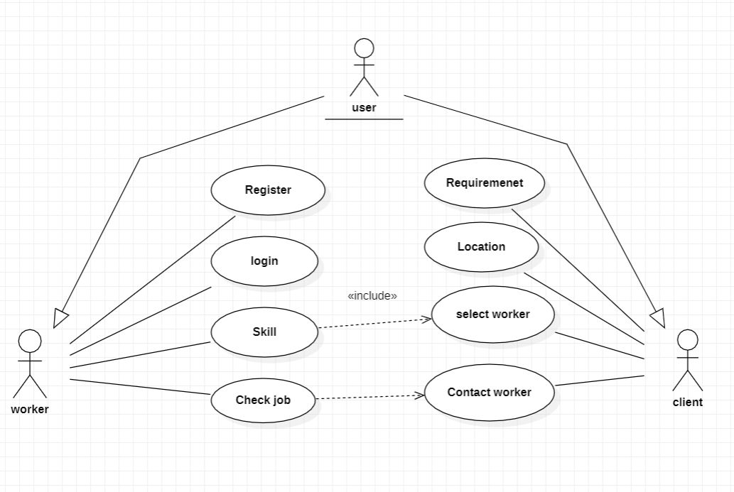

**3.2 Activity Diagram**

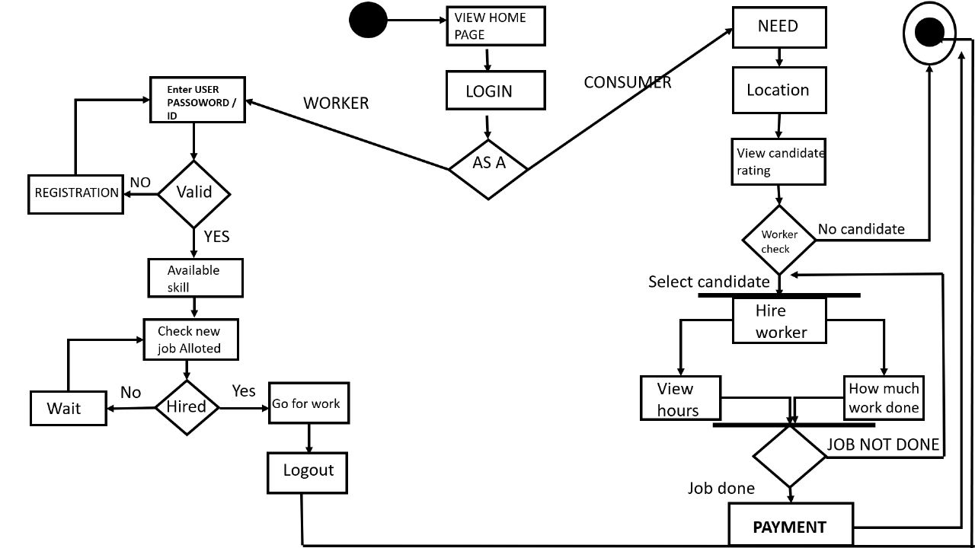

**3.3 E-R Diagram**

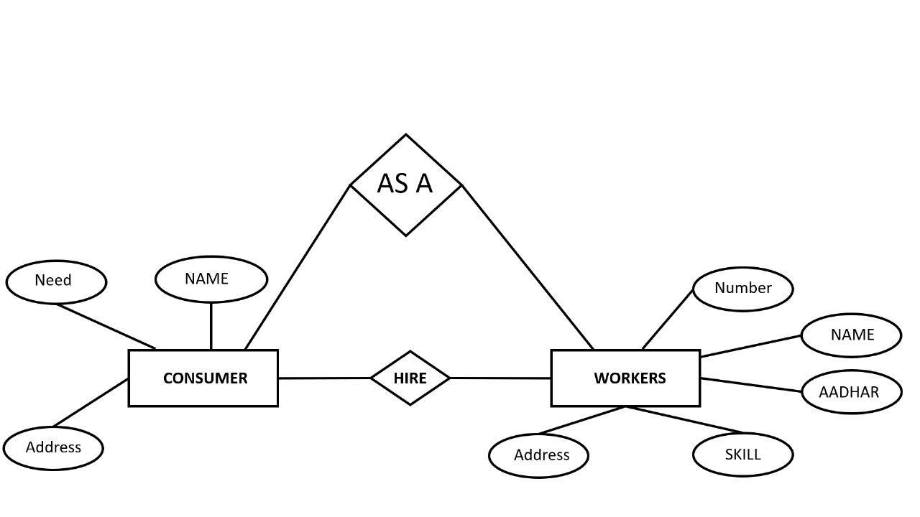

**3.4 Class Diagram**

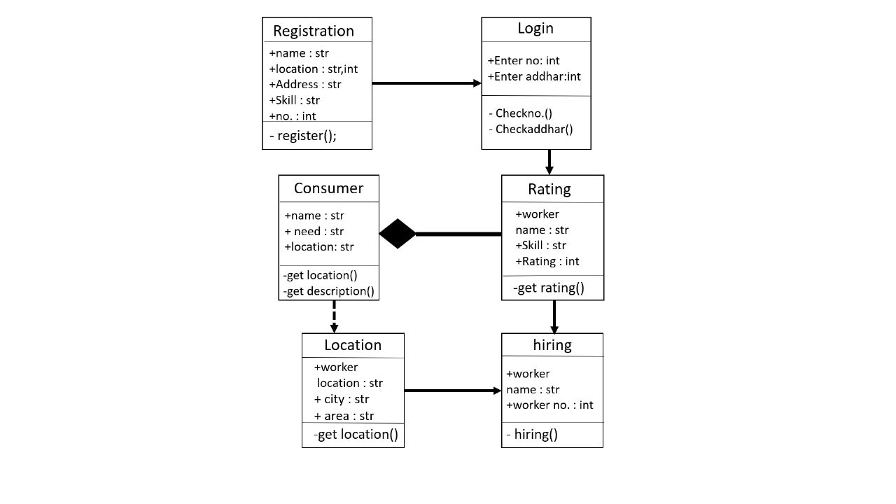

**3.5 Data flow diagram**

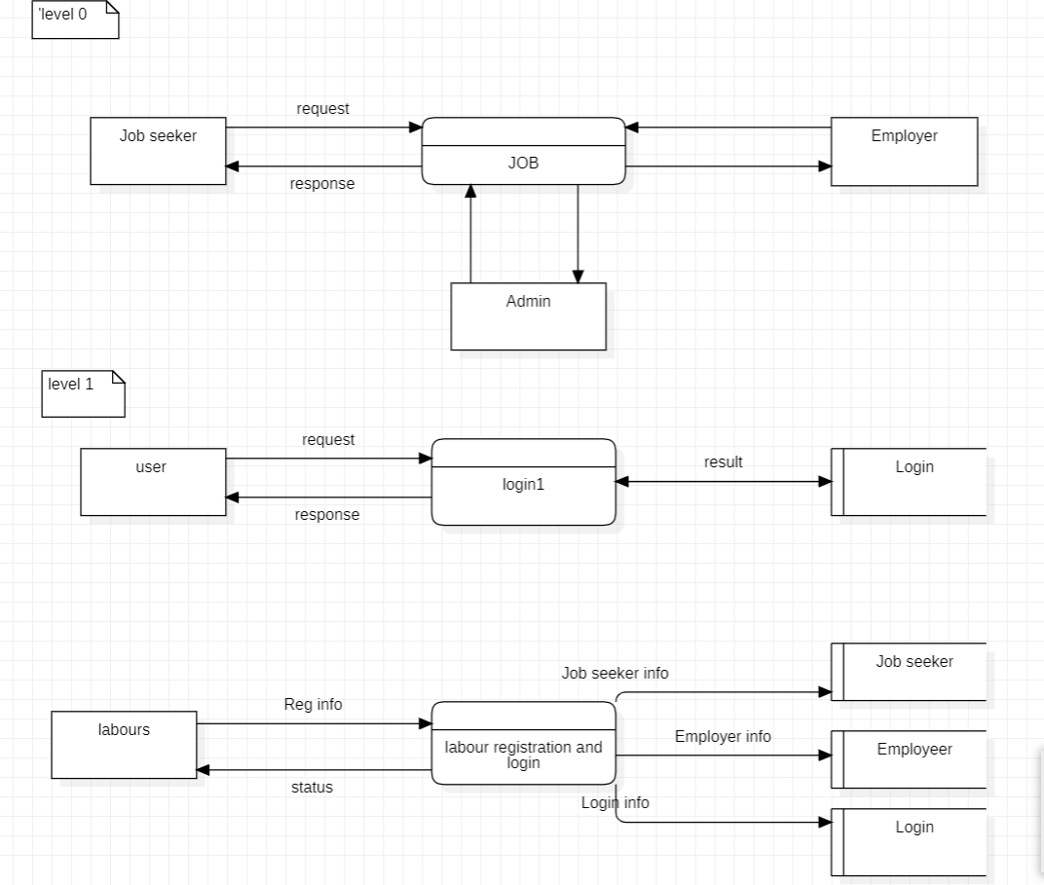

**3.6 Sequence diagram**

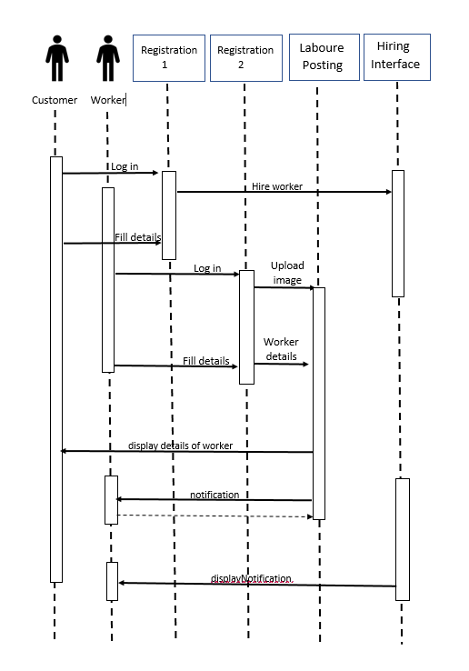

## Chapter 4: Construction

### Implementation

#### Implementation Details

This project is implemented on Android Studio IDE and it is totally based on android base application , for connectivity of Database we used firebase , firebase is inbuild available in the Android Studio IDE. We use authentication and realtime database .

**4.1.2 Database Tables**

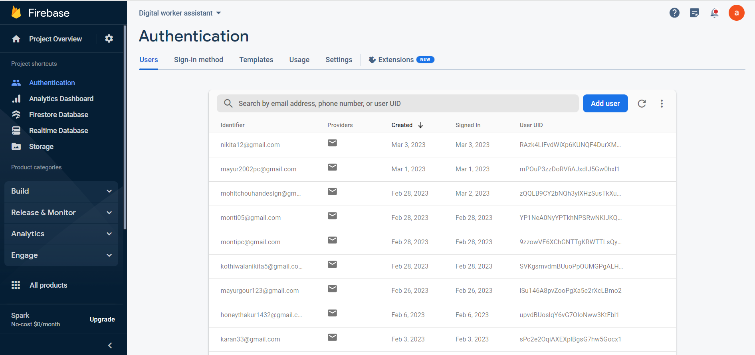

### Testing

#### White Box Testing

White-box testing is a method of [software testing](https://en.wikipedia.org/wiki/Software_testing) that tests internal structures or workings of an application, as opposed to its functionality (i.e. [black-box testing](https://en.wikipedia.org/wiki/Black-box_testing)). In white-box testing, an internal perspective of the system is used to design test cases. The tester chooses inputs to exercise paths through the code and determine the expected outputs. This is analogous to testing nodes in a circuit, e.g. [in-circuit testing](https://en.wikipedia.org/wiki/In-circuit_test) (ICT). White-box testing can be applied at the [unit,](https://en.wikipedia.org/wiki/Unit_testing) [integration](https://en.wikipedia.org/wiki/Integration_testing) and [system](https://en.wikipedia.org/wiki/System_testing) levels of the software testing process.

#### Black Box Testing

Black-box testing is a method of [software testing](https://en.wikipedia.org/wiki/Software_testing) that examines the functionality of an application without peering into its internal structures or workings. This method of test can be applied virtually to every level of software testing: [unit](https://en.wikipedia.org/wiki/Unit_test), [integration](https://en.wikipedia.org/wiki/Integration_testing), [system](https://en.wikipedia.org/wiki/System_testing) and [acceptance](https://en.wikipedia.org/wiki/Acceptance_test). It is sometimes referred to as specification-based testing.

#### Test Cases

* + - * Verify that the user is able to navigate through all the products across different categories.
      * Verify that all the links and banners are redirecting to the correct product/category pages and none of the links are broken.
      * Verify that all the information displayed – product name, category name, price, and product description is clearly visible.
      * Verify that all the images – product and banner are clearly visible.
      * Verify that category pages have a relevant product listed, specific to the category.
      * Verify that the correct count of total products is displayed on the category pages.
      * Search – Verify that on searching, all the products satisfying the search criteria are visible on the search result page.

**References**

On September 2020 UP government has created a app for migrate worker for employment. But due to some problems in their it cannot extend to a large scale.

So we will create a app which has many extra features which was not present in previous apps like we will add navigation which was not present in previous app we will also add language controllability and rating system.

We will try to make sure that our app can make huge impact in economic condition of India.

**Conclusion**

In the end we came to the conclusion that employment is the one of the basic need of the person and our application will somehow try to overcome this problem of unemployment that's why we are targeting the rural India. The labors are the main part of our economy so if our labors will get their work on regular basis the economic condition of India will become strong. The main motive of creating a bridge between worker and client. There is no language barrier in our application, our app

Will contain much domestic language which is spoken in India, so that every Indian citizen can use this application. In future we will try to add a section in which all notification of government schemes related to labor will show, so no one can miss the opportunity to get benefits from government schemes.